

Capstone Project Document

**FIRST AID**

**Report #2 – Software Requirement Specification**

|  |  |  |
| --- | --- | --- |
| **First Aid** | | |
| **Group Members** | Đàm Huy Hùng | SE03431 |
| Nguyễn Duy Anh | 01525 |
| Mai Trung Kiên | SE02994 |
| Nguyễn Tiến Dũng | SE03272 |
| Nguyễn Phúc An | SE03118 |
| **Supervisor** | Mr. Nguyễn Văn Sang | |
| **Project code** | FAVN | |

**- Hanoi, 09/2016 -**

# **SIGNATURE PAGE**

AUTHOR: Nguyễn Duy Anh 00/09/2016

Team member

REVIEWERS: Đàm Huy Hùng 00/09/2016

Project Manager

APPROVAL: Nguyễn Văn Sang --/--/--16

Supervisor

Record of change

*A - Added M - Modified D – Deleted

|  |  |  |  |  |  |
| --- | --- | --- | --- | --- | --- |
| Effective Date | Changed Item | A,M,D | Change Description | Reason for Change | Rev. Number |
| 01/10/2015 | Create Software Requirements Specifications | A | First version | Create Software Requirements Specifications | 1.0 |
| 02/10/2015 | Modify Business rule, Non-Functional specification | M | First version | Modify Software Requirements Specifications | 1.1 |
| 09/12/2015 | Modify Use case | M | First version | Modify Software Requirements Specifications | 1.2 |
|  |  |  |  |  |  |
|  |  |  |  |  |  |
|  |  |  |  |  |  |

**TABLE CONTENTS**

**SIGNATURE PAGE 2**

**1. INTRODUCTION 4**

1.1. Purpose 4

1.2. Definitions and Acronyms 4

1.3. System Purpose 5

**2.** **OVERALL DESCRIPTION 5**

2.1. System overview 5

2.2. Use Case Diagram 7

2.3. Product Features 7

2.3.1. User Characteristics 9

2.3.2. User Documentation 10

2.3.3. Assumption 10

2.4. Entity Relation Model 10

2.4.1. Entity-Relationship Diagram 10

2.4.2. Entity Detail 11

**3.** **FUNCTIONAL SPECIFICATION** 14

3.1. Business Rules 14

3.2. Use Cases 16

3.2.1. Guest/ Registered Group Function 16

3.2.2. Guest Group Function 36

3.2.3. Registered Group Function 38

3.2.4. Administrator Group Function 54

**4.** **NON-FUNCTIONAL SPECIFICATION** 96

4.1. Reliability 96

4.2. Performance Requirements 96

4.2.1. Availability 96

4.2.2. Response time 96

4.2.3. Maintainability 96

4.2.4. Usability 97

4.2.5. Security Requirements 97

4.2.6. Hardware/Software Requirements 97

# **INTRODUCTION**

## **Purpose**

This document is created as the introduction for project First Aid – our Capstone Project at FPT University. In this document, we provide the describing of general requirement and non-functional requirements. These requirements will ensure that the system will correctly and reliably perform its intended functionality. This specification will provide general, as well as specific requirements to be used in the design, testing and validation of the system. It is intended for both stakeholders and the project team of the system.

## **Definitions and Acronyms**

|  |  |  |
| --- | --- | --- |
| **Acronym** | **Definition** | **Note** |
| FAS | First Aid system |  |
| FAA | First Aid application |  |
| SRS | Software Requirements Specifications |  |
| Admin | FAS’s administrator |  |

Table 2-1: Definition and Acronyms

## **System Purpose**

For the purpose of offering Vietnamese people effective methods in emergencies, as well as help the community better understand what is aid and the importance of first aid, we implement a project to develop an application that can be like an assistance for users, called First Aid. In First Aid application, we can solve the limitations of hard copy documents and other products. Besides, we provide first aid’s step-by-step instructions to make sure that even untrained people can understand and follow. In addition, users can make SOS calling and find nearby hospitals and other useful features for life saving.

# **OVERALL DESCRIPTION**

## **System overview**

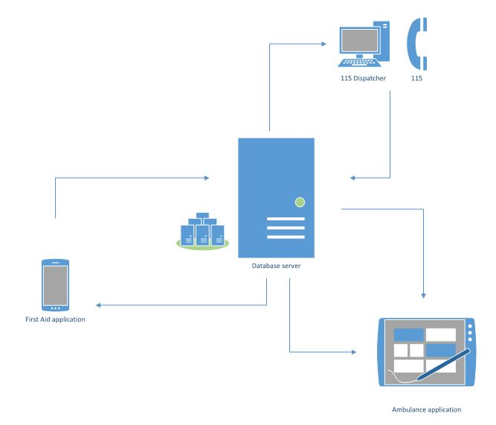

Figure 2-1: System Overview

## **Product Features**

### **First Aid Application**

|  |  |  |  |
| --- | --- | --- | --- |
| UC No. | Group Of Functions | Function | Glossary |
| First Aid Application | | | |
|  | Emergencies | View emergency list |  |
|  | View first aid of an emergency |  |
|  | Search emergencies |  |
|  | Call 115 |  |
|  | Speak first aid |  |
|  | View current location |  |
|  | View nearest hospital list |  |
|  | Direct to hospital |  |
|  | Call to hospital |  |
|  | Learning | View learning list |  |
|  | View learning detail |  |
|  | View FAQs |  |
|  | More | Sent question |  |
|  | View notification |  |
|  | View first aid course |  |
|  | Share application |  |
|  | Setting | Notify about update |  |
|  | Send information |  |
|  | Info | View application information |  |

Table 2-2-1: List of use case

### **Dispatcher**

|  |  |  |  |  |
| --- | --- | --- | --- | --- |
| UC No. | Group Of Functions | Function | Glossary | |
| Dispatcher | | | | |
|  | Common | Login | |  |
|  | Logout | |  |
|  | Dispatch | Create emergency case | |  |
|  | Dispatch an ambulance | |  |
|  | View ambulance | | info, status, location |
|  | View caller | | info |
|  | View direction from ambulance to caller | |  |
|  | View caller list | |  |
|  | Cancel dispatch | |  |

Table 2-2-2: List of use case

### **Ambulance Application**

|  |  |  |  |  |  |
| --- | --- | --- | --- | --- | --- |
| UC No. | Group Of Functions | | Function | Glossary | |
| Ambulance Application | | | | | |
|  | Common | Login | | |  |
|  | Logout | | |  |
|  | Emergency | View status ambulance team | | |  |
|  | Notify task | | |  |
|  | View the location of caller | | |  |
|  | View direction to caller | | |  |
|  | Report picked up caller | | |  |
|  | Report completed task | | |  |
|  | Report problem | | |  |
|  | Change status | | |  |

Table 2-2-3: List of use case

### **Administration**

|  |  |  |  |  |  |
| --- | --- | --- | --- | --- | --- |
| UC No. | Group Of Functions | | Function | | Glossary |
| Administration | | | | | |
| Admin | | | | | |
|  | Common | Admin login | |  | |
|  | Admin logout | |  | |
|  | Manage user's account | Create account | |  | |
|  | View list user | |  | |
|  | View user profile | |  | |
|  | Search user's account | |  | |
|  | Update user’s account | |  | |
|  | Delete user’s account | |  | |
|  | Manage Q&A | View user’s question | |  | |
|  | View answer | |  | |
|  | View FAQs | |  | |
|  | Answer question | |  | |
| Expert | | | | | |
|  | Common | Login | |  | |
|  | Logout | |  | |
|  | Manage Q&A | View user’s question | |  | |
|  | View answer | |  | |
|  | View FAQs | |  | |
|  | Answer the question | |  | |
|  | Manage first aid | Add new first aid | |  | |
|  | Search first aid | |  | |
|  | Update first aid | |  | |
|  | Delete first aid | |  | |
|  | Add new learning | |  | |
|  | Search learning | |  | |
|  | Update learning | |  | |
|  | Delete learning | |  | |

Table 2-2-4: List of use case

## **User Characteristics**

FAS has three objective users:

* **FAA user:** Users uses First Aid application in android mobile.
* **Dispatcher:** Users are offered an account by admin to use Dispatcher website.
* **Ambulance staff:** Users are offered an account by admin to use Ambulance application in tablet.
* **Expert:** Users are offered an account by admin to use First Aid website, they can manage all information about first aid and learning of emergencies, answer the question of FAA users.
* **Admin:** They can manage all information about all user types, answer the question of FAA users.

## **User Documentation**

|  |  |
| --- | --- |
| Name | Description |
| User Guide | Provide detailed explanation about the system, screens and guide users how to use all features of FA System. |

Table 2-3: User Documentation

## **Assumption**

* Receive the guidance and good support of teacher.
* No one of member got sick in the software development process.
* In the development process, no device got fail.
* Every report, task meets the deadline.
* Team member do not conflict in the work process.

## **Entity Relation Model**

### **Entity-Relationship Diagram**

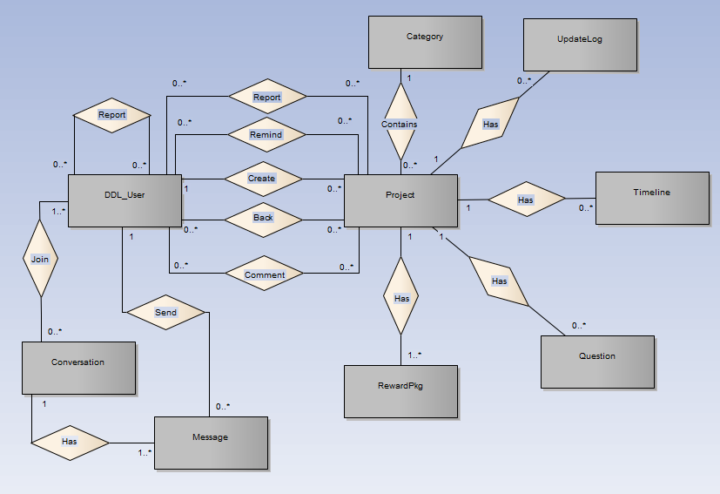

**Figure 2-3:** Entity Relationship Diagram

### **Entity Detail**

#### DDL_User

|  |  |  |  |  |
| --- | --- | --- | --- | --- |
| No | Attribute | Type | Mandatory | Description |
|  | UserID | Int | Y | User’s ID |
|  | UserName | String | Y | User’s name |
|  | Password | String | Y | User’s password |
|  | IsActive | Boolean | Y | User’s active status (inactive, active) |
|  | CreatedDate | Date | Y | User’s created date |
|  | LoginType | String | Y | User’s created type includes: normal, Facebook or both |
|  | LastLogin | Date | Y | User’s last login |
|  | UserType | String | Y | User’s type (admin or normal user) |
|  | IsVerify | Boolean | Y | User’ email verify status |
|  | VerifyCode | String | Y | User’s verify code |
|  | Email | String | Y | User’s email |

Table 2-4: DDL-User

#### Project

|  |  |  |  |  |
| --- | --- | --- | --- | --- |
| No | Attribute | Type | Mandatory | Description |
|  | ProjectID | Int | Y | Project’s ID |
|  | ProjectCode | String | Y | Project’s code with fixed format |
|  | CategoryID | Int | Y | Project’s category |
|  | UserID | Int | Y | Project’s UserID who created project |
|  | ProjectTitle | String | Y | Project’s title |
|  | Risk | String | Y | Project’s risk |
|  | ImageLink | String | Y | Project’s image link |
|  | SubDescription | String | Y | Project’s sub description |
|  | Location | String | Y | Project’s location created |
|  | IsExpired | Boolean | Y | Is Project’s expired |
|  | CurrentFunded | Decimal | Y | Project’s funded status |
|  | IsFunded | Boolean | Y | Is Project’s funded |
|  | CreatedDate | Date | Y | Project’s created date |
|  | ExpiredDate | Date | Y | Project’s expired date |
|  | FundingGoal | Decimal | Y | Project’s funding goal |
|  | Description | String | Y | Project’s description |
|  | LinkVideo | String | Y | Project’s video link |
|  | Story | String | Y | Project’s story |
|  | PopularPoint | Int | Y | Project’s popular point |
|  | Status | String | Y | Project’s status ( draft, pending, approved, suspended) |
|  | UpdatedDate | Date |  | Project’s updatedDate |

Table 2-5: Project

#### Category

|  |  |  |  |  |
| --- | --- | --- | --- | --- |
| No | Attribute | Type | Mandatory | Description |
| 1. 1 | CategoryID | Int | Y | Category’s ID |
| 1. 2 | Name | String | Y | Category’s name |
| 1. 3 | IsActive | Boolean | Y | Category’s active status |
|  | Description | String | Y | Category’s description |

Table 2-6: Category

#### UpdateLog table

|  |  |  |  |  |
| --- | --- | --- | --- | --- |
| No | Attribute | Type | Mandatory | Description |
| 1. 1 | UpdateID | Int | Y | Update’s ID |
| 1. 2 | ProjectID | Int | Y | Update’s project id |
| 1. 3 | Title | String | Y | Update’s title |
|  | Description | String | Y | Update’s description |
|  | CreatedDate | Date | Y | Update’s createdDate |

Table 2-7: UpdateLog table

#### Timeline table

|  |  |  |  |  |
| --- | --- | --- | --- | --- |
| No | Attribute | Type | Mandatory | Description |
| 1. 1 | TimelineID | Int | Y | Timeline’s ID |
| 1. 2 | ProjectID | Int | Y | Timeline’s project id |
| 1. 3 | Title | String | Y | Timeline’s title |
|  | Description | String | Y | Timeline’s description |
|  | DueDate | Date | Y | Timeline’s due date |
|  | ImageUrl | String | Y | Timeline’s Image Url |

Table 2-8: Timeline table

#### Question table

|  |  |  |  |  |
| --- | --- | --- | --- | --- |
| No | Attribute | Type | Mandatory | Description |
| 1. 1 | QuestionID | Number | Y | Question and answer’s ID |
| 1. 2 | ProjectID | Number | Y | Question and answer’s project id |
| 1. 3 | Question | String | Y | Question and answer’s question |
|  | Answer | String | Y | Question and answer’s answer |
|  | CreatedDate | Date | Y | Question and answer’s created date |

Table 2-9: Caption table

#### Reward package table

|  |  |  |  |  |
| --- | --- | --- | --- | --- |
| No | Attribute | Type | Mandatory | Description |
| 1. 1 | RewardID | Int | Y | Reward’s ID |
| 1. 2 | ProjectID | Int | Y | Reward’s project id |
| 1. 3 | LimitedQuantity | String | Y | Reward’s limited quantity |
|  | Type | String | Y | Reward’s type |
|  | Description | String | Y | Reward’s description |
|  | EstimatedDeliveryDate | Date | Y | Reward’s estimated delivery date |
|  | IsHide | Boolean | Y | Is Reward hide |
|  | CurrentQuantity | int | Y | Reward’s current quantity |
|  | PledgeAmount | Decimal | Y | Reward’s PledgeAmount |

Table 2-10: Reward package table

#### Message table

|  |  |  |  |  |
| --- | --- | --- | --- | --- |
| No | Attribute | Type | Mandatory | Description |
| 1. 1 | MessageID | Number | Y | Message’s ID |
| 1. 2 | ConversationID | Number | Y | Message’s conversation id |
| 1. 3 | UserID | Number | Y | Message’s user id |
|  | MessageContent | String | Y | Message’s content |
|  | SentTime | Date | Y | Message’s sent time |

Table 2-11: Message table

#### Conversation table

|  |  |  |  |  |
| --- | --- | --- | --- | --- |
| No | Attribute | Type | Mandatory | Description |
|  | ConversationID | Number | Y | Conversation’s ID |
|  | CreatorID | Number | Y | Conversation’s creator id |
|  | ReceiverID | Number | Y | Conversation’s receiver |
|  | Subject | String | Y | Conversation’s subject |
|  | CreatedDate | Date | Y | Conversation’s created date |
|  | UpdatedDate | Date | Y | Conversation’s update date |
|  | DeleteStatus | String | Y | Conversation’s user delete status |
|  | ViewStatus | String | Y | Conversation’s user view status |

Table 2-12: Conversation table

# **FUNCTIONAL SPECIFICATION**

## **Business Rules**

|  |  |
| --- | --- |
| **No** | **Description** |
|  |  |
|  |  |
|  |  |
|  |  |
|  |  |
|  |  |
|  |  |
|  |  |
|  |  |
|  |  |
|  |  |
|  |  |
|  |  |
|  |  |
|  |  |
|  |  |
|  |  |
|  |  |

Table 2-13: Business rules

## **Use Cases**

### **First Aid Application Function**

#### Emergencies Module

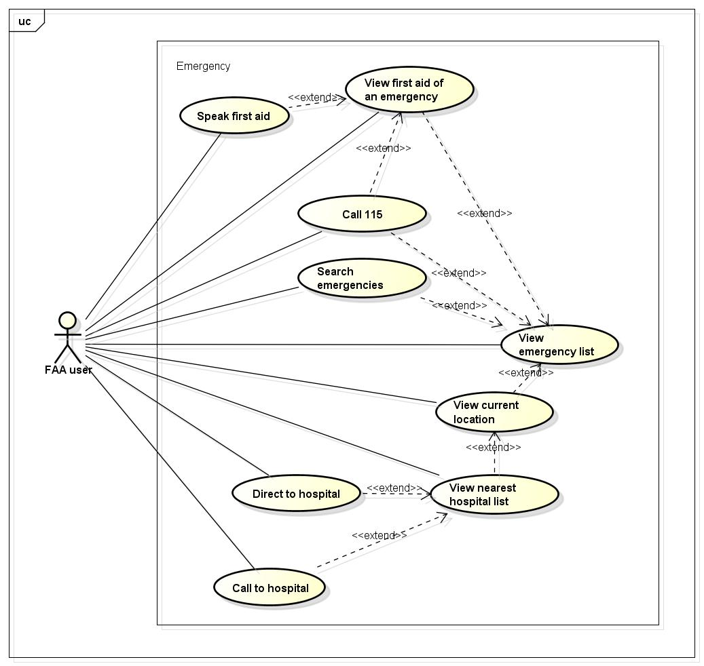

Figure -4: Emergencies use case

##### UC001 - View emergency list

|  |  |  |  |  |
| --- | --- | --- | --- | --- |
| **Use Case ID** | | UC001 | **Version** | 1.1 |
| **Use Case Name** | | View emergency list | | |
| **Created by:** | | AnhND | **Date Created:** | 24/09/2016 |
| **Primary Actor** | | FAA user | **Secondary Actor** |  |
| **Description:** | | This function allows customer to view all emergencies need to first aid in First Aid application. | | |
| **Preconditions:** | | Install First Aid application | | |
| **Trigger:** | | Customer launch application | | |
| **Post conditions:** | | All existing emergencies will be displayed in the mobile screen. | | |
| **Normal Flow** | | | | |
| **Step** | **Actor** | **Action** | | |
| 1 | Customer | Launch application | | |
| 2 | FAA | List all existing emergencies | | |
| **Alternative Flows: N/A** | | | | |
| **Exceptions: N/A** | | | | |
| **Priority** | | High | | |
| **Frequency of Use:** | | High | | |
| **Business Rules:** | |  | | |
| **Other Information:** | | N/A | | |

Table 2- 4: View emergency list

##### UC002 - View first aid of an emergency

|  |  |  |  |  |
| --- | --- | --- | --- | --- |
| **Use Case ID** | | UC002 | **Version** | 1.1 |
| **Use Case Name** | | View first aid of an emergency | | |
| **Created by:** | | AnhND | **Date Created:** | 24/09/2016 |
| **Primary Actor** | | FAA user | **Secondary Actor** |  |
| **Description:** | | This function allows customer to view first aid step instructions of an emergency. | | |
| **Preconditions:** | | 1. Install First Aid application 2. Customer launch application | | |
| **Trigger:** | | Customer taps on an emergency in the list emergencies that displayed in the mobile screen. | | |
| **Post conditions:** | | All first aid step instructions about this emergency will be displayed in the mobile screen. | | |
| **Normal Flow** | | | | |
| **Step** | **Actor** | **Action** | | |
| 1 | Customer | Launch application | | |
| 2 | Customer | Tap on an emergency in the list | | |
| 3 | FAA | Show all first aid step instructions | | |
| **Alternative Flows:** | | | | |
| **AT1** | At step 2 in the main flows, if customer taps on other buttons. | | | |
| **Step** | **Actor** | **Action** | | |
| 2.1 | FAA | Redirects customer to chosen button. | | |
| **Exceptions: N/A** | | | | |
| **Priority** | | High | | |
| **Frequency of Use:** | | High | | |
| **Business Rules:** | |  | | |
| **Other Information:** | | N/A | | |

Table 2- 4: View first aid of an emergency

##### UC003 - Search emergencies

|  |  |  |  |  |
| --- | --- | --- | --- | --- |
| **Use Case ID** | | UC003 | **Version** | 1.1 |
| **Use Case Name** | | Search emergencies | | |
| **Created by:** | | AnhND | **Date Created:** | 24/09/2016 |
| **Primary Actor** | | FAA user | **Secondary Actor** |  |
| **Description:** | | This function allows customer to search an emergency exits on FAA by text | | |
| **Preconditions:** | | 1. Install First Aid application 2. Customer launch application | | |
| **Trigger:** | | Customer taps on search button, enters search phrase and taps Search | | |
| **Post conditions:** | | All results that matched with the keyword customer enters will be displayed in the mobile screen | | |
| **Normal Flow** | | | | |
| **Step** | **Actor** | **Action** | | |
| 1 | Customer | Tap on search button | | |
| 2 | Customer | Enter search phrase to text box | | |
| 3 | Customer | Tap Search | | |
| 4 | DDL | List all results that matched with the keyword customer entered | | |
| **Alternative Flows:** | | | | |
| **AT1** | At step 2 in the main flows, if customer taps on an emergency in the list under the text box. | | | |
| **Step** | **Actor** | **Action** | | |
| 2.1 | FAA | Redirects customer to first aid step instructions of chosen emergency. | | |
|  | | | | |
| **AT2** | At step 2 in the main flows, if customer taps on back button. | | | |
| **Step** | **Actor** | **Action** | | |
| 2.1 | FAA | Redirects customer to emergencies screen | | |
|  | | | | |
| **AT3** | At step 3 in the main flows, if customer taps on [x] button | | | |
| **Step** | **Actor** | **Action** | | |
| 3.1 | FAA | Redirects customer to text box to enters search phrase | | |
| **Exceptions: N/A** | | | | |
| **Priority** | | High | | |
| **Frequency of Use:** | | High | | |
| **Business Rules:** | |  | | |
| **Other Information:** | | N/A | | |

Table 2- 15: Search emergencies

##### UC004 - Call 115

|  |  |  |  |  |
| --- | --- | --- | --- | --- |
| **Use Case ID** | | UC004 | **Version** | 1.1 |
| **Use Case Name** | | Call 115 | | |
| **Created by:** | | AnhND | **Date Created:** | 24/09/2016 |
| **Primary Actor** | | FAA user | **Secondary Actor** |  |
| **Description:** | | This function allows customer to make emergency calls to the 115 center. | | |
| **Preconditions:** | | 1. Install First Aid application 2. Customer launch application | | |
| **Trigger:** | |  | | |
| **Post conditions:** | |  | | |
| **Normal Flow** | | | | |
| **Step** | **Actor** | **Action** | | |
| 1 | Customer | Launch application | | |
| 2 | Customer |  | | |
| 3 | FAA |  | | |
| **Alternative Flows:** | | | | |
| **AT1** |  | | | |
| **Step** | **Actor** | **Action** | | |
|  |  |  | | |
| **Exceptions: N/A** | | | | |
| **Priority** | | High | | |
| **Frequency of Use:** | | High | | |
| **Business Rules:** | |  | | |
| **Other Information:** | | N/A | | |

Table 2- 15: Call 115

##### UC005 - Speak first aid

|  |  |  |  |  |
| --- | --- | --- | --- | --- |
| **Use Case ID** | | UC005 | **Version** | 1.1 |
| **Use Case Name** | | View current location | | |
| **Created by:** | | AnhND | **Date Created:** | 24/09/2016 |
| **Primary Actor** | | FAA user | **Secondary Actor** |  |
| **Description:** | | This function allows customer to locate their current location correctly. | | |
| **Preconditions:** | | 1. Install First Aid application 2. Customer launch application | | |
| **Trigger:** | |  | | |
| **Post conditions:** | |  | | |
| **Normal Flow** | | | | |
| **Step** | **Actor** | **Action** | | |
| 1 | Customer | Launch application | | |
| 2 | Customer |  | | |
| 3 | FAA |  | | |
| **Alternative Flows:** | | | | |
| **AT1** |  | | | |
| **Step** | **Actor** | **Action** | | |
|  |  |  | | |
| **Exceptions: N/A** | | | | |
| **Priority** | | High | | |
| **Frequency of Use:** | | High | | |
| **Business Rules:** | |  | | |
| **Other Information:** | | N/A | | |

Table 2- 15: View current location

##### UC006 - View current location

|  |  |  |  |  |
| --- | --- | --- | --- | --- |
| **Use Case ID** | | UC006 | **Version** | 1.1 |
| **Use Case Name** | | View current location | | |
| **Created by:** | | AnhND | **Date Created:** | 24/09/2016 |
| **Primary Actor** | | FAA user | **Secondary Actor** |  |
| **Description:** | | This function allows customer to locate their current location correctly. | | |
| **Preconditions:** | | 1. Install First Aid application 2. Customer launch application | | |
| **Trigger:** | |  | | |
| **Post conditions:** | |  | | |
| **Normal Flow** | | | | |
| **Step** | **Actor** | **Action** | | |
| 1 | Customer | Launch application | | |
| 2 | Customer |  | | |
| 3 | FAA |  | | |
| **Alternative Flows:** | | | | |
| **AT1** |  | | | |
| **Step** | **Actor** | **Action** | | |
|  |  |  | | |
| **Exceptions: N/A** | | | | |
| **Priority** | | High | | |
| **Frequency of Use:** | | High | | |
| **Business Rules:** | |  | | |
| **Other Information:** | | N/A | | |

Table 2- 15: View current location

##### UC007 - View nearest hospital list

|  |  |  |  |  |
| --- | --- | --- | --- | --- |
| **Use Case ID** | | UC007 | **Version** | 1.1 |
| **Use Case Name** | | View nearest hospital list | | |
| **Created by:** | | AnhND | **Date Created:** | 24/09/2016 |
| **Primary Actor** | | FAA user | **Secondary Actor** |  |
| **Description:** | | This function allows customer to view nearest hospital list from their location. | | |
| **Preconditions:** | | 1. Install First Aid application 2. Customer launch application | | |
| **Trigger:** | |  | | |
| **Post conditions:** | |  | | |
| **Normal Flow** | | | | |
| **Step** | **Actor** | **Action** | | |
| 1 | Customer | Launch application | | |
| 2 | Customer |  | | |
| 3 | FAA |  | | |
| **Alternative Flows:** | | | | |
| **AT1** |  | | | |
| **Step** | **Actor** | **Action** | | |
|  |  |  | | |
| **Exceptions: N/A** | | | | |
| **Priority** | | High | | |
| **Frequency of Use:** | | High | | |
| **Business Rules:** | |  | | |
| **Other Information:** | | N/A | | |

Table 2- 15: View nearest hospital list

##### UC008 - Direct to hospital

|  |  |  |  |  |
| --- | --- | --- | --- | --- |
| **Use Case ID** | | UC008 | **Version** | 1.1 |
| **Use Case Name** | | Direct to hospital | | |
| **Created by:** | | AnhND | **Date Created:** | 24/09/2016 |
| **Primary Actor** | | FAA user | **Secondary Actor** |  |
| **Description:** | | This function allows customer to view nearest hospital list from their location. | | |
| **Preconditions:** | | 1. Install First Aid application 2. Customer launch application | | |
| **Trigger:** | |  | | |
| **Post conditions:** | |  | | |
| **Normal Flow** | | | | |
| **Step** | **Actor** | **Action** | | |
| 1 | Customer | Launch application | | |
| 2 | Customer |  | | |
| 3 | FAA |  | | |
| **Alternative Flows:** | | | | |
| **AT1** |  | | | |
| **Step** | **Actor** | **Action** | | |
|  |  |  | | |
| **Exceptions: N/A** | | | | |
| **Priority** | | High | | |
| **Frequency of Use:** | | High | | |
| **Business Rules:** | |  | | |
| **Other Information:** | | N/A | | |

Table 2- 15: Direct to hospital

##### UC009 - Call to hospital

|  |  |  |  |  |
| --- | --- | --- | --- | --- |
| **Use Case ID** | | UC009 | **Version** | 1.1 |
| **Use Case Name** | | Call hospital | | |
| **Created by:** | | AnhND | **Date Created:** | 24/09/2016 |
| **Primary Actor** | | FAA user | **Secondary Actor** |  |
| **Description:** | | This function allows customer to call to the hospital | | |
| **Preconditions:** | | 1. Install First Aid application 2. Customer launch application | | |
| **Trigger:** | |  | | |
| **Post conditions:** | |  | | |
| **Normal Flow** | | | | |
| **Step** | **Actor** | **Action** | | |
| 1 | Customer | Launch application | | |
| 2 | Customer |  | | |
| 3 | FAA |  | | |
| **Alternative Flows:** | | | | |
| **AT1** |  | | | |
| **Step** | **Actor** | **Action** | | |
|  |  |  | | |
| **Exceptions: N/A** | | | | |
| **Priority** | | High | | |
| **Frequency of Use:** | | High | | |
| **Business Rules:** | |  | | |
| **Other Information:** | | N/A | | |

Table 2- 15: Call to hospital

#### Learning Module

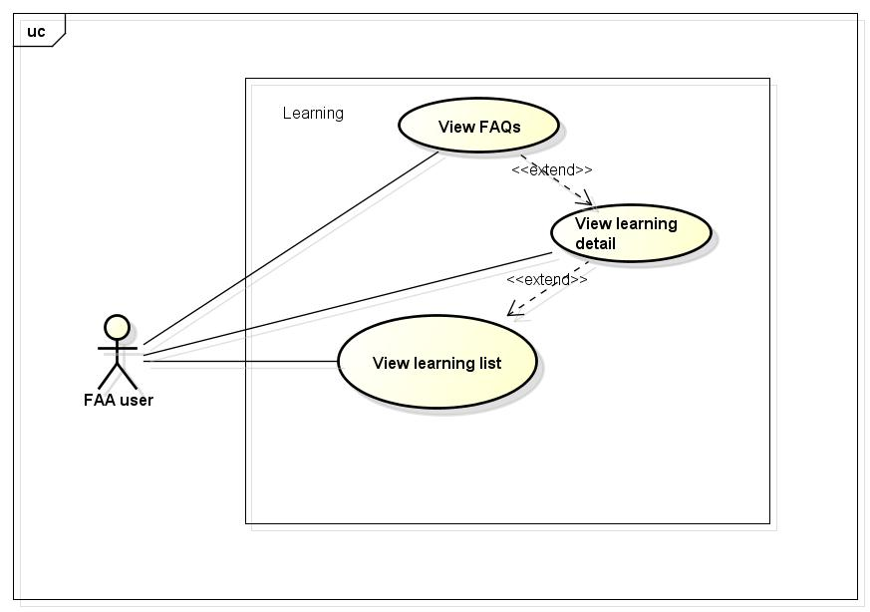

Figure -5: Learning use case

##### UC0010 - View learning list

|  |  |  |  |  |
| --- | --- | --- | --- | --- |
| **Use Case ID** | | UC0010 | **Version** | 1.1 |
| **Use Case Name** | | View learning list | | |
| **Created by:** | | AnhND | **Date Created:** | 24/09/2016 |
| **Primary Actor** | | FAA user | **Secondary Actor** |  |
| **Description:** | | This function allows customer to call to the hospital | | |
| **Preconditions:** | | 1. Install First Aid application 2. Customer launch application | | |
| **Trigger:** | |  | | |
| **Post conditions:** | |  | | |
| **Normal Flow** | | | | |
| **Step** | **Actor** | **Action** | | |
| 1 | Customer | Launch application | | |
| 2 | Customer |  | | |
| 3 | FAA |  | | |
| **Alternative Flows:** | | | | |
| **AT1** |  | | | |
| **Step** | **Actor** | **Action** | | |
|  |  |  | | |
| **Exceptions: N/A** | | | | |
| **Priority** | | High | | |
| **Frequency of Use:** | | High | | |
| **Business Rules:** | |  | | |
| **Other Information:** | | N/A | | |

Table 2- 15: View learning list

##### UC0011 - View learning detail

|  |  |  |  |  |
| --- | --- | --- | --- | --- |
| **Use Case ID** | | UC0011 | **Version** | 1.1 |
| **Use Case Name** | | View learning detail | | |
| **Created by:** | | AnhND | **Date Created:** | 24/09/2016 |
| **Primary Actor** | | FAA user | **Secondary Actor** |  |
| **Description:** | | This function allows customer to call to the hospital | | |
| **Preconditions:** | | 1. Install First Aid application 2. Customer launch application | | |
| **Trigger:** | |  | | |
| **Post conditions:** | |  | | |
| **Normal Flow** | | | | |
| **Step** | **Actor** | **Action** | | |
| 1 | Customer | Launch application | | |
| 2 | Customer |  | | |
| 3 | FAA |  | | |
| **Alternative Flows:** | | | | |
| **AT1** |  | | | |
| **Step** | **Actor** | **Action** | | |
|  |  |  | | |
| **Exceptions: N/A** | | | | |
| **Priority** | | High | | |
| **Frequency of Use:** | | High | | |
| **Business Rules:** | |  | | |
| **Other Information:** | | N/A | | |

Table 2- 17: View learning detail

##### UC0012 - View FAQs

|  |  |  |  |  |
| --- | --- | --- | --- | --- |
| **Use Case ID** | | UC0012 | **Version** | 1.1 |
| **Use Case Name** | | View FAQs | | |
| **Created by:** | | AnhND | **Date Created:** | 24/09/2016 |
| **Primary Actor** | | FAA user | **Secondary Actor** |  |
| **Description:** | | This function allows customer to call to the hospital | | |
| **Preconditions:** | | 1. Install First Aid application 2. Customer launch application | | |
| **Trigger:** | |  | | |
| **Post conditions:** | |  | | |
| **Normal Flow** | | | | |
| **Step** | **Actor** | **Action** | | |
| 1 | Customer | Launch application | | |
| 2 | Customer |  | | |
| 3 | FAA |  | | |
| **Alternative Flows:** | | | | |
| **AT1** |  | | | |
| **Step** | **Actor** | **Action** | | |
|  |  |  | | |
| **Exceptions: N/A** | | | | |
| **Priority** | | High | | |
| **Frequency of Use:** | | High | | |
| **Business Rules:** | |  | | |
| **Other Information:** | | N/A | | |

Table 2- 18: View FAQs

#### More Module

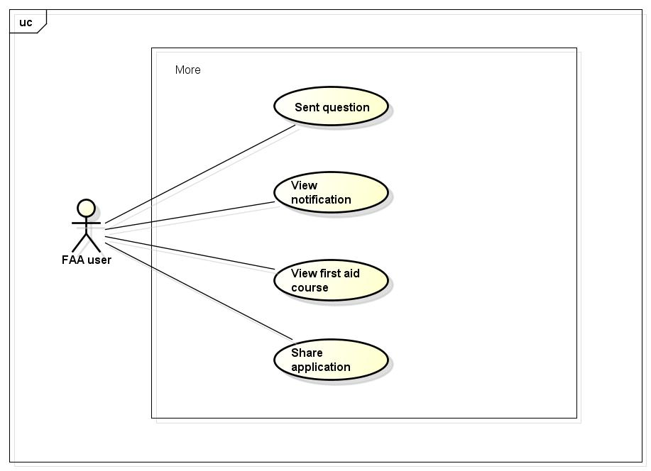

##### UC0013 - Sent question

|  |  |  |  |  |
| --- | --- | --- | --- | --- |
| **Use Case ID** | | UC0013 | **Version** | 1.1 |
| **Use Case Name** | | Sent question | | |
| **Created by:** | | AnhND | **Date Created:** | 24/09/2016 |
| **Primary Actor** | | FAA user | **Secondary Actor** |  |
| **Description:** | | This function allows customer to call to the hospital | | |
| **Preconditions:** | | 1. Install First Aid application 2. Customer launch application | | |
| **Trigger:** | |  | | |
| **Post conditions:** | |  | | |
| **Normal Flow** | | | | |
| **Step** | **Actor** | **Action** | | |
| 1 | Customer | Launch application | | |
| 2 | Customer |  | | |
| 3 | FAA |  | | |
| **Alternative Flows:** | | | | |
| **AT1** |  | | | |
| **Step** | **Actor** | **Action** | | |
|  |  |  | | |
| **Exceptions: N/A** | | | | |
| **Priority** | | High | | |
| **Frequency of Use:** | | High | | |
| **Business Rules:** | |  | | |
| **Other Information:** | | N/A | | |

Table 2- 19: Sent question

##### UC0014 - View notification

|  |  |  |  |  |
| --- | --- | --- | --- | --- |
| **Use Case ID** | | UC0014 | **Version** | 1.1 |
| **Use Case Name** | | View notification | | |
| **Created by:** | | AnhND | **Date Created:** | 24/09/2016 |
| **Primary Actor** | | FAA user | **Secondary Actor** |  |
| **Description:** | | This function allows customer to call to the hospital | | |
| **Preconditions:** | | 1. Install First Aid application 2. Customer launch application | | |
| **Trigger:** | |  | | |
| **Post conditions:** | |  | | |
| **Normal Flow** | | | | |
| **Step** | **Actor** | **Action** | | |
| 1 | Customer | Launch application | | |
| 2 | Customer |  | | |
| 3 | FAA |  | | |
| **Alternative Flows:** | | | | |
| **AT1** |  | | | |
| **Step** | **Actor** | **Action** | | |
|  |  |  | | |
| **Exceptions: N/A** | | | | |
| **Priority** | | High | | |
| **Frequency of Use:** | | High | | |
| **Business Rules:** | |  | | |
| **Other Information:** | | N/A | | |

Table 2- 19: View notification

##### UC0015 - View first aid course

|  |  |  |  |  |
| --- | --- | --- | --- | --- |
| **Use Case ID** | | UC0015 | **Version** | 1.1 |
| **Use Case Name** | | View first aid course | | |
| **Created by:** | | AnhND | **Date Created:** | 24/09/2016 |
| **Primary Actor** | | FAA user | **Secondary Actor** |  |
| **Description:** | | This function allows customer to call to the hospital | | |
| **Preconditions:** | | 1. Install First Aid application 2. Customer launch application | | |
| **Trigger:** | |  | | |
| **Post conditions:** | |  | | |
| **Normal Flow** | | | | |
| **Step** | **Actor** | **Action** | | |
| 1 | Customer | Launch application | | |
| 2 | Customer |  | | |
| 3 | FAA |  | | |
| **Alternative Flows:** | | | | |
| **AT1** |  | | | |
| **Step** | **Actor** | **Action** | | |
|  |  |  | | |
| **Exceptions: N/A** | | | | |
| **Priority** | | High | | |
| **Frequency of Use:** | | High | | |
| **Business Rules:** | |  | | |
| **Other Information:** | | N/A | | |

Table 2- 19: View first aid course

##### UC0016 - Share application

|  |  |  |  |  |
| --- | --- | --- | --- | --- |
| **Use Case ID** | | UC0016 | **Version** | 1.1 |
| **Use Case Name** | | Share application | | |
| **Created by:** | | AnhND | **Date Created:** | 24/09/2016 |
| **Primary Actor** | | FAA user | **Secondary Actor** |  |
| **Description:** | | This function allows customer to call to the hospital | | |
| **Preconditions:** | | 1. Install First Aid application 2. Customer launch application | | |
| **Trigger:** | |  | | |
| **Post conditions:** | |  | | |
| **Normal Flow** | | | | |
| **Step** | **Actor** | **Action** | | |
| 1 | Customer | Launch application | | |
| 2 | Customer |  | | |
| 3 | FAA |  | | |
| **Alternative Flows:** | | | | |
| **AT1** |  | | | |
| **Step** | **Actor** | **Action** | | |
|  |  |  | | |
| **Exceptions: N/A** | | | | |
| **Priority** | | High | | |
| **Frequency of Use:** | | High | | |
| **Business Rules:** | |  | | |
| **Other Information:** | | N/A | | |

Table 2- 19: Share application

#### Setting module

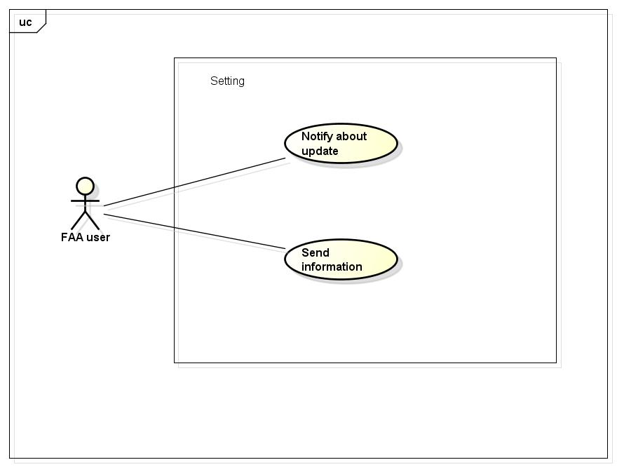

##### UC0017 - Notify about update

|  |  |  |  |  |
| --- | --- | --- | --- | --- |
| **Use Case ID** | | UC0017 | **Version** | 1.1 |
| **Use Case Name** | | Notify about update | | |
| **Created by:** | | AnhND | **Date Created:** | 24/09/2016 |
| **Primary Actor** | | FAA user | **Secondary Actor** |  |
| **Description:** | | This function allows customer to call to the hospital | | |
| **Preconditions:** | | 1. Install First Aid application 2. Customer launch application | | |
| **Trigger:** | |  | | |
| **Post conditions:** | |  | | |
| **Normal Flow** | | | | |
| **Step** | **Actor** | **Action** | | |
| 1 | Customer | Launch application | | |
| 2 | Customer |  | | |
| 3 | FAA |  | | |
| **Alternative Flows:** | | | | |
| **AT1** |  | | | |
| **Step** | **Actor** | **Action** | | |
|  |  |  | | |
| **Exceptions: N/A** | | | | |
| **Priority** | | High | | |
| **Frequency of Use:** | | High | | |
| **Business Rules:** | |  | | |
| **Other Information:** | | N/A | | |

Table 2- 19: Notify about update

##### UC0018 - Send information

|  |  |  |  |  |
| --- | --- | --- | --- | --- |
| **Use Case ID** | | UC0018 | **Version** | 1.1 |
| **Use Case Name** | | Send information | | |
| **Created by:** | | AnhND | **Date Created:** | 24/09/2016 |
| **Primary Actor** | | FAA user | **Secondary Actor** |  |
| **Description:** | | This function allows customer to call to the hospital | | |
| **Preconditions:** | | 1. Install First Aid application 2. Customer launch application | | |
| **Trigger:** | |  | | |
| **Post conditions:** | |  | | |
| **Normal Flow** | | | | |
| **Step** | **Actor** | **Action** | | |
| 1 | Customer | Launch application | | |
| 2 | Customer |  | | |
| 3 | FAA |  | | |
| **Alternative Flows:** | | | | |
| **AT1** |  | | | |
| **Step** | **Actor** | **Action** | | |
|  |  |  | | |
| **Exceptions: N/A** | | | | |
| **Priority** | | High | | |
| **Frequency of Use:** | | High | | |
| **Business Rules:** | |  | | |
| **Other Information:** | | N/A | | |

Table 2- 19: Send information

#### Info Module

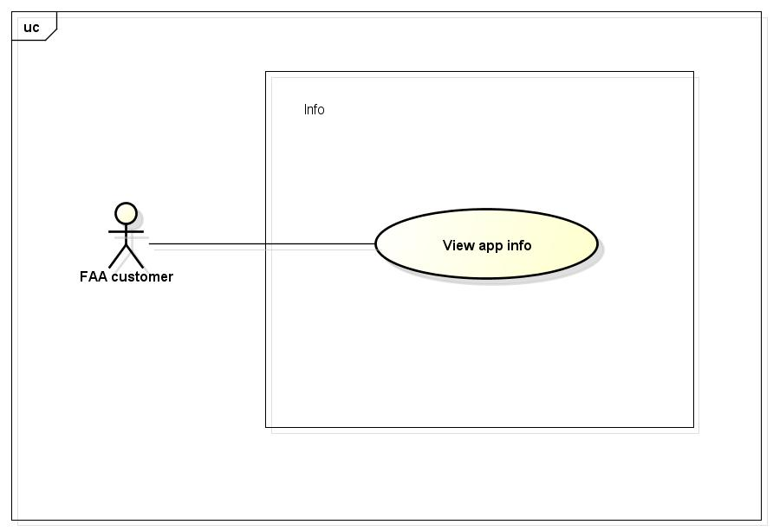

##### UC0019 - View app info

|  |  |  |  |  |
| --- | --- | --- | --- | --- |
| **Use Case ID** | | UC0019 | **Version** | 1.1 |
| **Use Case Name** | | View app info | | |
| **Created by:** | | AnhND | **Date Created:** | 24/09/2016 |
| **Primary Actor** | | FAA user | **Secondary Actor** |  |
| **Description:** | | This function allows customer to call to the hospital | | |
| **Preconditions:** | | 1. Install First Aid application 2. Customer launch application | | |
| **Trigger:** | |  | | |
| **Post conditions:** | |  | | |
| **Normal Flow** | | | | |
| **Step** | **Actor** | **Action** | | |
| 1 | Customer | Launch application | | |
| 2 | Customer |  | | |
| 3 | FAA |  | | |
| **Alternative Flows:** | | | | |
| **AT1** |  | | | |
| **Step** | **Actor** | **Action** | | |
|  |  |  | | |
| **Exceptions: N/A** | | | | |
| **Priority** | | High | | |
| **Frequency of Use:** | | High | | |
| **Business Rules:** | |  | | |
| **Other Information:** | | N/A | | |

Table 2- 19: View app info

### **Dispatcher Function**

#### Common Module

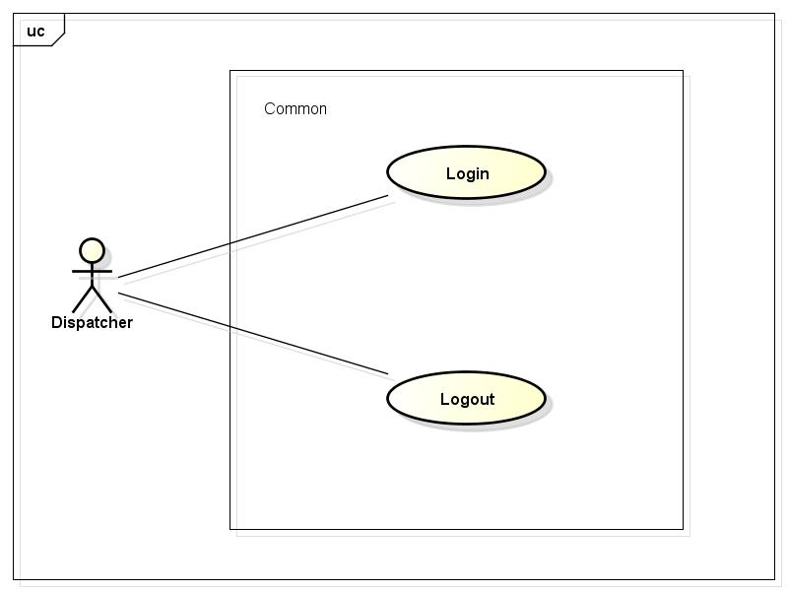

##### UC0020 - Login

|  |  |  |  |  |
| --- | --- | --- | --- | --- |
| **Use Case ID** | | UC0020 | **Version** | 1.1 |
| **Use Case Name** | | Login | | |
| **Created by:** | | AnhND | **Date Created:** | 24/09/2016 |
| **Primary Actor** | | FAA user | **Secondary Actor** |  |
| **Description:** | | This function allows customer to call to the hospital | | |
| **Preconditions:** | | 1. Install First Aid application 2. Customer launch application | | |
| **Trigger:** | |  | | |
| **Post conditions:** | |  | | |
| **Normal Flow** | | | | |
| **Step** | **Actor** | **Action** | | |
| 1 | Customer | Launch application | | |
| 2 | Customer |  | | |
| 3 | FAA |  | | |
| **Alternative Flows:** | | | | |
| **AT1** |  | | | |
| **Step** | **Actor** | **Action** | | |
|  |  |  | | |
| **Exceptions: N/A** | | | | |
| **Priority** | | High | | |
| **Frequency of Use:** | | High | | |
| **Business Rules:** | |  | | |
| **Other Information:** | | N/A | | |

Table 2- 19: Login

##### UC0021 - Logout

|  |  |  |  |  |
| --- | --- | --- | --- | --- |
| **Use Case ID** | | UC0021 | **Version** | 1.1 |
| **Use Case Name** | | Logout | | |
| **Created by:** | | AnhND | **Date Created:** | 24/09/2016 |
| **Primary Actor** | | FAA user | **Secondary Actor** |  |
| **Description:** | | This function allows customer to call to the hospital | | |
| **Preconditions:** | | 1. Install First Aid application 2. Customer launch application | | |
| **Trigger:** | |  | | |
| **Post conditions:** | |  | | |
| **Normal Flow** | | | | |
| **Step** | **Actor** | **Action** | | |
| 1 | Customer | Launch application | | |
| 2 | Customer |  | | |
| 3 | FAA |  | | |
| **Alternative Flows:** | | | | |
| **AT1** |  | | | |
| **Step** | **Actor** | **Action** | | |
|  |  |  | | |
| **Exceptions: N/A** | | | | |
| **Priority** | | High | | |
| **Frequency of Use:** | | High | | |
| **Business Rules:** | |  | | |
| **Other Information:** | | N/A | | |

Table 2- 19: Logout

#### Dispatch Module

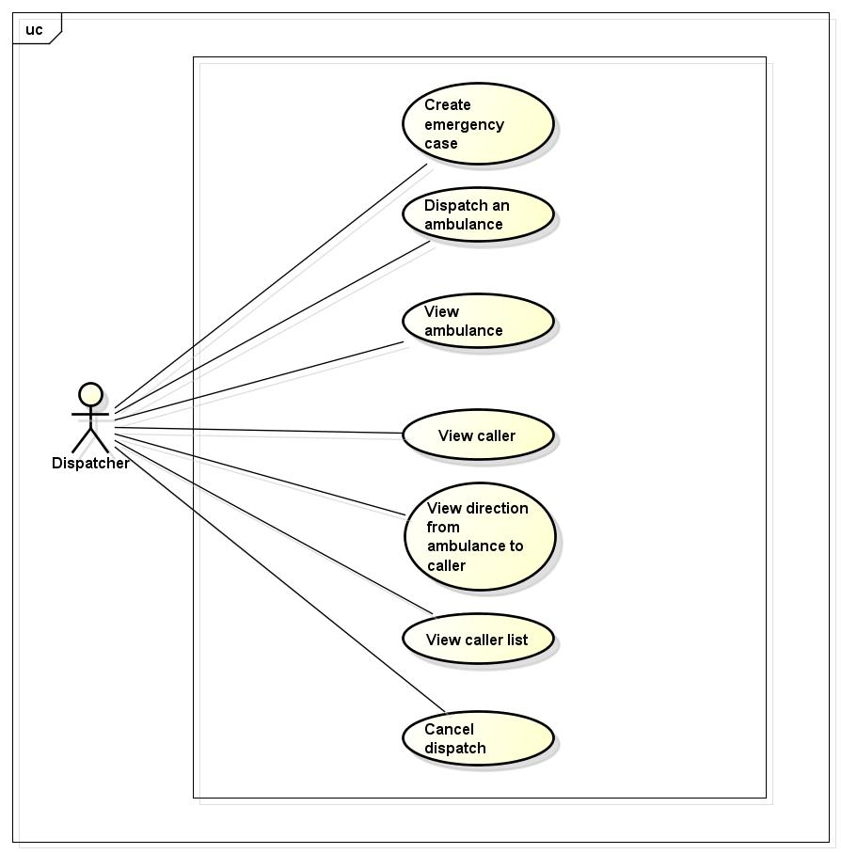

### **Ambulance Application Function**

### **Administration Function**

# **NON-FUNCTIONAL SPECIFICATION**

## **Reliability**

1. Mean time between failures: The mean time between each failure is expected to be about 480 hours of using.
2. The maximum bugs per function are 2 bugs/a function when user uses software within 2 months. The average number of bugs in the software during system testing is about to be around 1 bugs/KLOC.
3. The database must be backed up daily and can be recovered if necessary

## **Performance Requirements**

### **Availability**

The application must be available 95% of time. Users can access to it everywhere from their

Web browser with internet connection.

### **Response time**

In term of response time, waiting time of processing will be 2 to 5 seconds; time to process any functions will not exceed 7 seconds.

## **Maintainability**

* **Coding standards and naming conventions**
  + Output of the project must include coding standards and naming conventions documentations. Implementation code must be easy to maintain.
  + If some components are reused, the documentations of those components must also be included.
* **Design**
  + The design of the system must be loosely coupled that chances on some module will not affect others.
* **Logging**
  + All the errors should be logged, supporting for bug fixing and maintenance.
  + All strange or sensitive situations should also be logged.
* **Mean time to repair:** Immediately when Administrator finds out problem or website is attacked/ hacked by someone. Average 1 day.

## **Usability**

Usability Requirements support the following from the perspective of its primary users:

● **Efficiency of use:** user can complete each function in less than 12 actions

● **Intuitiveness:** User can understand approximately 90% help/ error messages

## **Security Requirements**

In order to avoid unwanted access by strangers, the security implemented in various ways:

1. **User authorize**: Each function must be distributed system access and manipulate the individual parts. To edit information, user must declare their username and password before the operation. Functions will be show after users login dependencies user’s role and permission of each user.
2. **Manage Data Layer**: Only Administrator can modify database system.

## **Hardware/Software Requirements**

● **Hardware requirement:**

**- Server:** Web service 2013, IIS8

**- Client:** PC/Laptop (window 7, window 8)

● **Software requirements:** Web browser (Chrome 40.0, Firefox 30.0) with internet connection